

**Name: Muhammad Fahad**

**Sap ID: 37125**

**Section: BSCS-5A**

**Course: Advance computer programming**

**Lab task#1**

Code file Github link: https://github.com/fahadmoon/5th-Semester/tree/java/Lab%20Task/Lab%201

1. Write a program to reverse a number in Java.

import java.util.Scanner;  
public class Main {  
 public static void main(String[] args) {  
 Scanner obj=new Scanner(System.*in*);  
 System.*out*.println("What is the number of entries?");  
 int no=obj.nextInt();  
 System.*out*.println("Enter element of array");  
 int[] array=new int[no];  
 for(int i=0;i<no;i++){  
 array[i]=obj.nextInt();  
 }  
  
 for(int i=no-1;i>=0;i--){  
 System.*out*.print(array[i]+" ");  
 }  
 }  
}

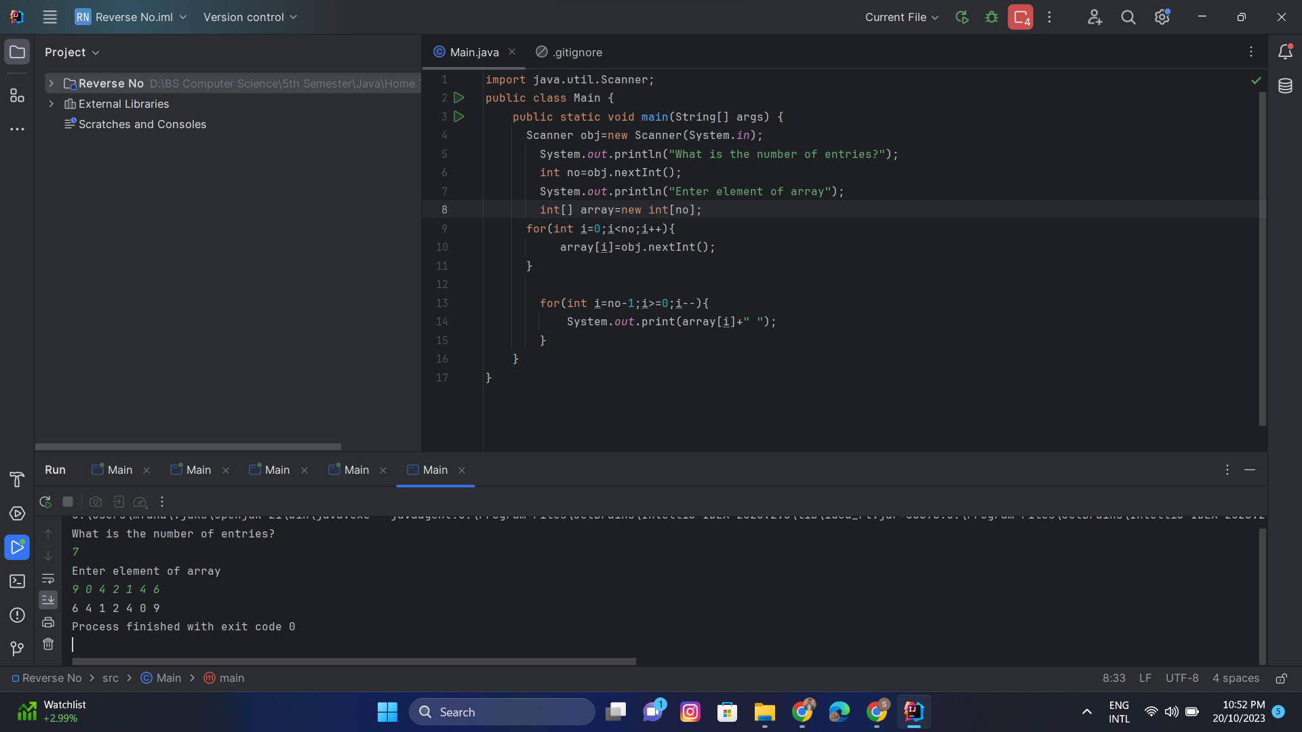

2. Write a program to calculate factorial of a given number.

import java.util.Scanner;  
public class Main {  
 public static void main(String[] args) {  
 Scanner obj=new Scanner(System.*in*);  
 System.*out*.println("Enter factorial no: ");  
 int f=obj.nextInt();  
 int a=1;  
 for(int i=1;i<=f;i++)  
 {  
 a=a*i;  
 }  
 System.*out*.println("Factorial of "+ f+ " is "+ a);  
 }  
}

